INTRODUCTION:

Overviwe:

India is the world's third-largest producer and third-largest consumer of electricity. The national electric grid in India has an installed capacity of 370.106 GW as of 31 March 2020. Renewable power plants, which also include large hydroelectric plants, constitute 35.86% of India's total installed capacity. During the fiscal year (FY) 2019–20, the total electricity generation in the country was 1,598 TWh, of which 1,383.5 TWh generated by utilities. The gross electricity consumption per capita in FY2019 was 1,208 kWh.

Purpose:

In 2015-16, electric energy consumption in agriculture was recorded as being the highest (17.89%) worldwide. The per capita electricity consumption is low compared to most other countries despite India having a low electricity tariff.

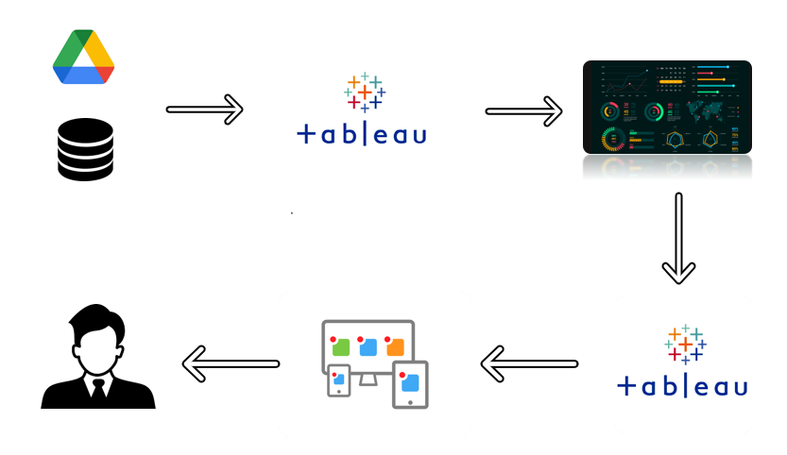

PROBLEM DEFINITION & DESIGN THINKING:

Ideation and brainstorming:



RESULT:

Screenshot:

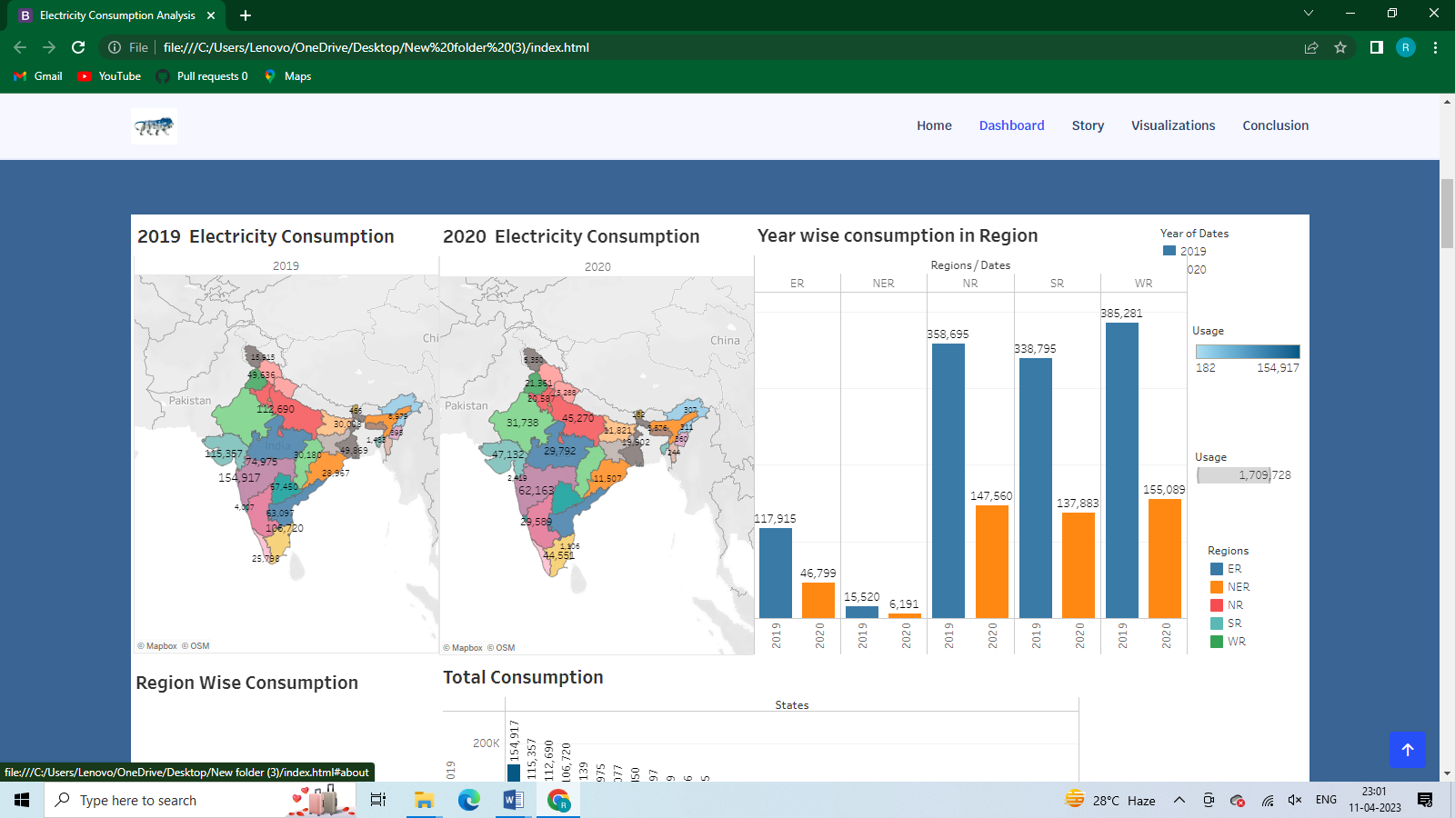

ADVANTAGES & DISADVANTAGES:

**Advantages of electricity :**

* It is a clean, safe, cheap and convenient source of energy
* Lower maintenance cost
* More efficient
* No tailpipe emission
* We all know that it  can be set up in many sizes
* It doesn't require as many employees
* Reduces greenhouse emission
* Makes barely any pollution compare to other ways of creating or generating electricity
* Relatively low maintenance cost
* Hydroelectric station are inexpensive to operate
* Hydroelectricity produces no gas emissions or waste
* A station can operate and run for long periods of time
* It is renewable

**Disadvantages of electricity :**

* More expensive than gasoline
* Loss of fish species
* Sometimes messes up wildlife
* Dependent on precipitation
* More power plants and more pollution
* Damming can cause loss of land suitable for agriculture as well as recreation
* Cost for construction
* Change in river or stream quality
* An electric vehicle is not completely emission free
* In electricity, there are a limited number of feasible sites for a large number of dams
* Drought can affect power production
* Hydroelectric natural seasonal changes in river and ecosystems can be destroyed

APPLICATION:

People use electricity for

lighting,

heating,

cooling,

refrigeration and

for operating appliances,

computers,

electronics,

machinery, and

public transportation systems.

Energy analysis can provide information on the quantity of energy input/output of a system. Exergy analysis, on the other hand, offers information on both the quantity and quality of all inputs/outputs within a system. Exergy analysis helps researchers identify the points where energy loses its quality.

Cooling and heating: 47% of energy use.

Water heater: 14% of energy use.

Washer and dryer: 13% of energy use.

Lighting: 12% of energy use.

Refrigerator: 4% of energy use.

Electric oven: 3-4% of energy use.

TV, DVD, cable box: 3% of energy use.

Dishwasher: 2% of energy use.

CONCLUTION:

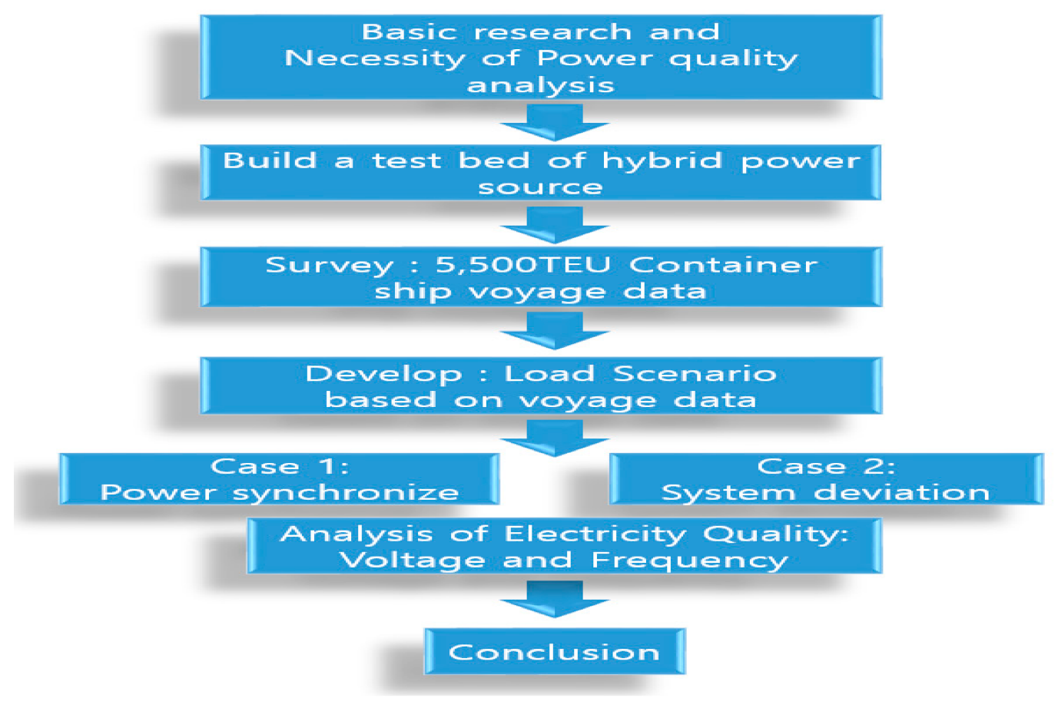

FUTRUE SCOPE:

The future prospects of the EEE graduates are very wide and bright. The demand for environmentally friendly power generation, more sophisticated electrical and electronic devices, and cheaper and smarter products mean there is a lot of work for Electrical Engineers. There are a wide range of challenging paths available to an Electrical engineer.

The areas they can fit in are Design and Development, Manufacturing, Automation, Production and Maintenance, Operation and Control of any equipments or products which work on electricity.

Electrical and Electronics Engineering graduates can work in various fields as Power engineering, Instrumentation Engineering, Communications engineering, Computer engineering and Media. The graduates from this discipline can pursue higher education in IITs, NITs, Deemed Universities and almost all State Universities and Private Engineering Colleges offering Specialized Courses, and also can write TOEFL and GRE for pursuing studies in abroad.

Some of the PG courses offered by different IIT’s/NIT’s and Universities for Electrical and Electronics Graduates in India:

* Power Electronics & Electrical Drives

* Power & Industrial Drives

* Power Engg. & Energy Systems

* Electrical Machines and Drives

* Power Systems with Emphasis on H.V. Engg. / Electrical Power Systems (HV) /H.V.Engg.

* Advanced Power Systems

* Instrumentation and Control Systems

* Energy Systems

* Power System Control and Automation

* Industrial Drives & Controls

* Power Systems & Power Electronics

* Power Systems Engg.

* Power Electronics

* Power Systems & Automation

* Control Systems

* Systems & Signal

* Digital Systems Engg

* Embedded Systems

* VLSI Design

* Computer Science Engineering

There are a number of good opportunities for getting jobs in India as well as abroad like in design and construction of power lines, in the control and management of power stations or in the design and installation of electrical systems and machinery, such as transformers, electric motors, power electronics and various private sector organizations.

Career opportunities include

* Industrial research and development labs

* Energy supply corporations

* Software and Services companies

* Civil Services

* Technical Monitoring Agencies

* Research Institutes and Educational institutions

As the electrical power generating sector is rapidly getting enhanced, the job prospects in power grid corporation of India, National thermal and hydro electric corporations, NEC, power stations run by private power corporations is very bright in the years to come.

The EEE students who have inclination towards Research and Development have fair opportunities in the R&D departments of the ministry of science and technology like ISRO, DRDL, DRDO.

APPENDIX:

Basic code for the html wed design:

|  |  |
| --- | --- |
|  |  |

<!doctype html>

<html lang="en">

<head>

<meta charset="utf-8">

<meta name="viewport" content="width=device-width, initial-scale=2">

<title>eletricity consumption</title>

<link rel="stylesheet" href="style.css">

<link href="https://cdn.jsdelivr.net/npm/bootstrap@5.3.0-alpha3/dist/css/bootstrap.min.css" rel="stylesheet" integrity="sha384-KK94CHFLLe+nY2dmCWGMq91rCGa5gtU4mk92HdvYe+M/SXH301p5ILy+dN9+nJOZ" crossorigin="anonymous">

</head>

</head>

<body>

<nav class="navbar navbar-expand-lg bg-body-tertiary">

<div class="container-fluid">

<a class="navbar-brand" href="#">electricity analysis</a>

<button class="navbar-toggler" type="button" data-bs-toggle="collapse" data-bs-target="#navbarNavAltMarkup" aria-controls="navbarNavAltMarkup" aria-expanded="false" aria-label="Toggle navigation">

<span class="navbar-toggler-icon"></span>

</button>

<div class="collapse navbar-collapse" id="navbarNavAltMarkup">

<div class="navbar-nav">

</div>

</div>

</div>

</nav>

<div class='tableauPlaceholder' id='viz1681061041836' style='position: relative'><noscript><a href='#'><img alt='Dashboard 5 ' src='https:&#47;&#47;public.tableau.com&#47;static&#47;images&#47;el&#47;electricityconsumptionanalysis&#47;Dashboard5&#47;1_rss.png' style='border: none' /></a></noscript><object class='tableauViz' style='display:none;'><param name='host_url' value='https%3A%2F%2Fpublic.tableau.com%2F' /> <param name='embed_code_version' value='3' /> <param name='site_root' value='' /><param name='name' value='electricityconsumptionanalysis&#47;Dashboard5' /><param name='tabs' value='no' /><param name='toolbar' value='yes' /><param name='static_image' value='https:&#47;&#47;public.tableau.com&#47;static&#47;images&#47;el&#47;electricityconsumptionanalysis&#47;Dashboard5&#47;1.png' /> <param name='animate_transition' value='yes' /><param name='display_static_image' value='yes' /><param name='display_spinner' value='yes' /><param name='display_overlay' value='yes' /><param name='display_count' value='yes' /><param name='language' value='en-GB' /></object></div> <script type='text/javascript'> var divElement = document.getElementById('viz1681061041836'); var vizElement = divElement.getElementsByTagName('object')[0]; if ( divElement.offsetWidth > 800 ) { vizElement.style.width='100%';vizElement.style.height=(divElement.offsetWidth*0.75)+'px';} else if ( divElement.offsetWidth > 500 ) { vizElement.style.width='100%';vizElement.style.height=(divElement.offsetWidth*0.75)+'px';} else { vizElement.style.width='100%';vizElement.style.height='1227px';} var scriptElement = document.createElement('script'); scriptElement.src = 'https://public.tableau.com/javascripts/api/viz_v1.js'; vizElement.parentNode.insertBefore(scriptElement, vizElement); </script>

<script src="https://cdn.jsdelivr.net/npm/bootstrap@5.3.0-alpha3/dist/js/bootstrap.bundle.min.js" integrity="sha384-ENjdO4Dr2bkBIFxQpeoTz1HIcje39Wm4jDKdf19U8gI4ddQ3GYNS7NTKfAdVQSZe" crossorigin="anonymous"></script>

</body>

</html>